# **Demo: Apache Kafka service in Aiven**

List of contents:

1. Introduction
2. Create a Kafka Service
3. Create a topic in Aiven Web console
4. Create a InfluxDB service and Grafana service
5. Metrics Integration of Kafka to InfluxDB
6. Integration of InfluxDB to Grafana
7. Access the Grafana console and view the Kafka Metrics

## Introduction:

This article walks you through creation of a simple Apache Kafka service and its configuration in Aiven to deploy a code that produces a JSON data to topic in the service. The message payload is a trigger event to utilize an Adaptive card feature for future integration with different tools and technologies like Webhook on Teams. The Kafka metrics are then integration with InfluxDB to further view the Kafka metrics on Grafana. Aiven services are accessible from the following <https://console.aiven.io/>

## Create a Kafka service:

Kafka service is created under the services tab and by performing the following commands:

* Select Create Service
* Select Apache Cassandra as a service
* Select a service cloud provider – In this case, we are using AWS cloud provider
* Specify cloud configuration properties. This includes:
  + Cloud region – Selected *United States, Virginia - Amazon Web Services: N. Virginia (us-east-1)* for this example
  + Service plan -Using a business plan of *Business-4 (2 CPU, 4 GB RAM, 600 GB storage, no backups) 3-node high availability set*
  + Additional disk space - None
  + Service name – Using the default name generated by service: *kafka-1fbd6a6a*

Once the service is configured, user can view the Service summary on the right side of the properties to ensure the selected configurations meets users’ requirements.

Upon selection of create Service under Service summary, a Kafka cluster in the given cloud region is deployed.



Once the service is up and running, check the connection information to perform any additional configurations like downloading the access key and certificates, enabling additional features, etc. In this example: Business service plan has been selected to enable Apache Kafka Connect which is not a feature provided for Startup service plan.



## Create a topic in Aiven Webconsole

A topic can be created in the Web console or via the Aiven command line interface. Refer to this section for Aiven-client installation command and instructions on usage.

Under topics -> Add a new topic and specify additional configurations in the Advanced Configuration based on requirements. The newly created topic will be populated under the Topic List. In this example, the created topic is “topic1”, with a replication factor of 3 with 3 partitions.

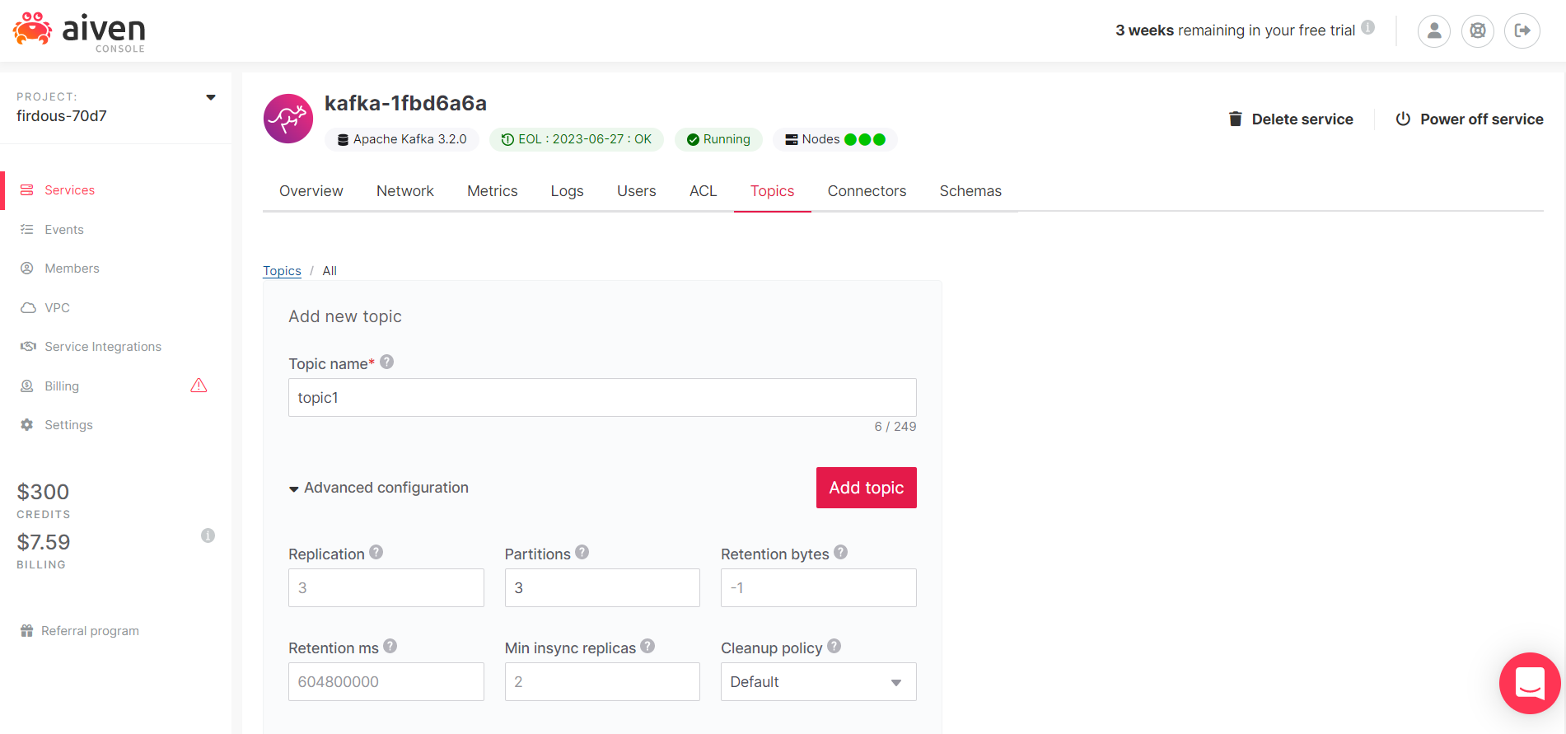

Select Topic -> Produce Messages to set Partition, Format, Key and Value information for producing messages

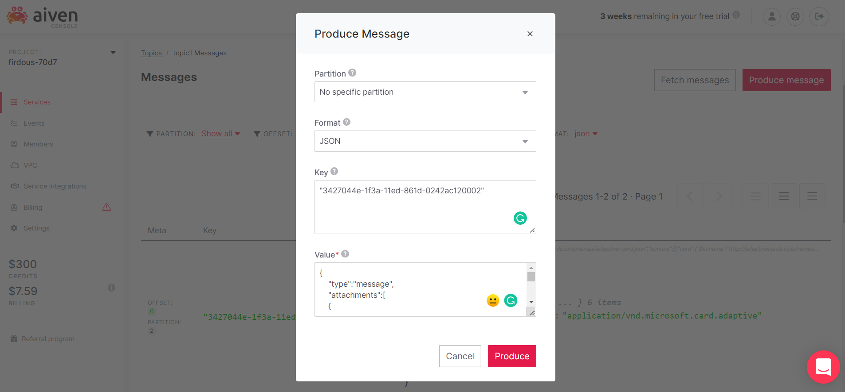

Select JSON format for fetching messages to display the key and value in JSON format. In this example, the Key is a random UUID created using a UUID generator and the Value is a JSON Adaptive card used for producing trigger notifications to different mediums like Teams and Slack.

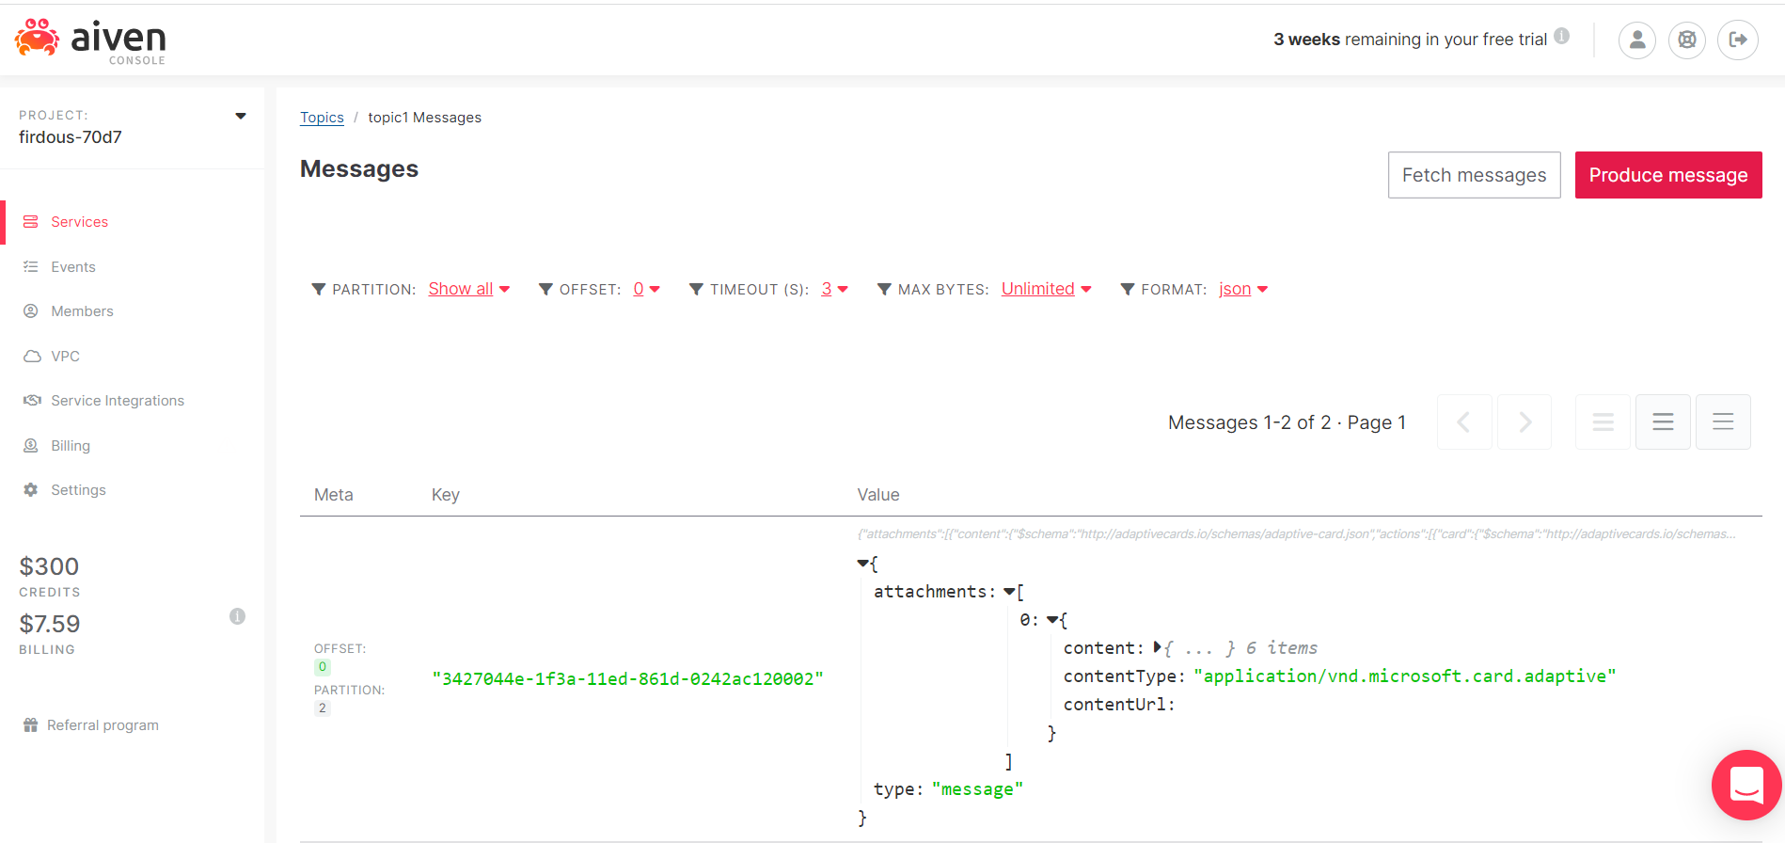

## 

## Create a InfluxDB service and Grafana service

Similar to creation of Kafka service, create a Grafana and Influx DB service in Aiven console.

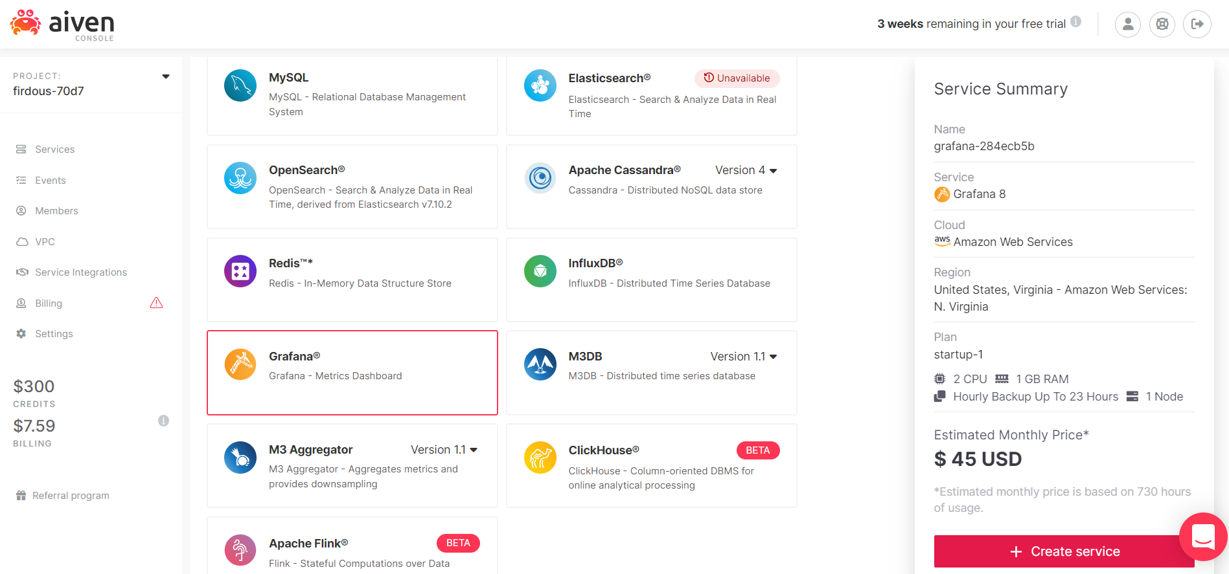

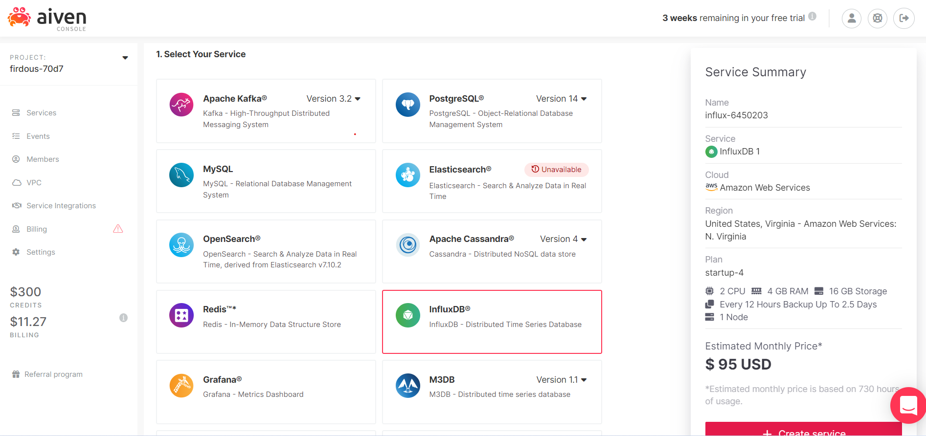

## Metrics Integration of Kafka to InfluxDB

Enable metrics integration to InfluxDB from the Kafka Metrics tab



## Integration of InfluxDB to Grafana

Enable InfluxDB integration with Grafana dashboard under Kafka metrics



## Access the Grafana console and view Kafka metrics

Click the Service URI in Grafana Connection Information and input the provided user and password to access the user interface. Save and test the created InfluxDB under data sources and view the Kafka metrics under dashboards.



